


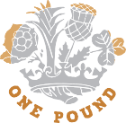
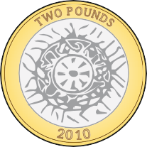
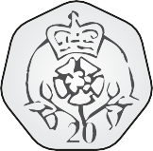
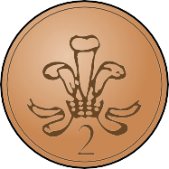


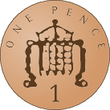
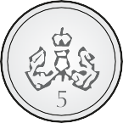
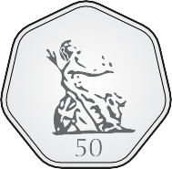


Recognising coins
2 pence
P
0
P
2
P
P
E
E
E
E
S
P
N
N
E
N
N
N
C
C
C
C
C
E
E
E
E
E
F
T
T
T
F
I
W
E
E
I
W
F
N
N
T
V
Y
T
T
O
E
Y
0
1

Match the coin to the amount.
1
O
U
N
D
W
O
P

20 pence
5 pence
10 pence
1 pound
1 pence
50 pence

2 pounds

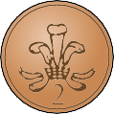
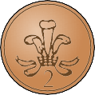


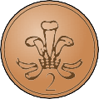





Here are some coins.
2
P
P
P
P
P
P
P
P
E
E
E
E
E
E
E
E
N
N
N
N
N
N
N
N
C
C
C
C
C
C
C
C
E
E
E
E
E
E
E
E
T
T
T
T
T
T
T
F
E
E
E
E
I
W
W
W
N
N
N
N
V
O
O
O
E


Complete the sentences.

There are 1p coins.

There are 2p coins.

There is 5p coin.

There are 10p coins.

There are 20p coins.


Write < or > to compare the amounts.
3

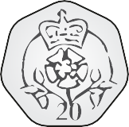
a)
P
E
P
N
E
N
C
C
E
E
T
T
W
E
E
N
N
T
Y

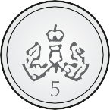
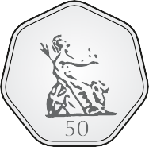
b)
P
P
E
E
N
N
C
C
E
E
F
F
I
I
F
V
T
E
Y

