Wednesday 03.02.21 and 10.02.21
LO: To create an information poster educating the people of Hong Kong about the major challenges facing the city.

Choose one natural challenge to Hong Kong. Use your device to follow the enquiry method, then create an information poster.
Natural challenge | Enquiry method
Typhoons  Heavy rain and flash floods  Landslides  Insects and snakes  Heat and humidity | What is your natural challenge?  When and where does it happen in Hong Kong?  What is done to protect people?  Why does it happen?

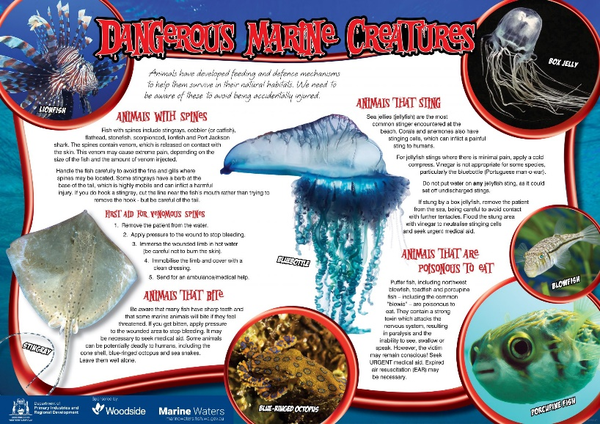
Examples of information posters

