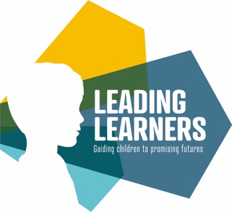

5th February 2021

Dear Parents / Carers

I hope you are all keeping well.

While, hopefully, we are seeing a light at the end of the tunnel as the Covid-19 vaccination programme roles out, we want to continue to develop our home learning offer. We simply want to better understand what is working well for our families, and where things can be enhanced further in the future.

That is why it would be fantastic if you could take a few moments to answer ten very short questions about the home learning offer that has been provided during our current lockdown. Our Trust and our staff have invested a lot of time and effort in trying to provide all of the support we can and getting a full understanding about the impact it has had, is really important.

You can visit the survey by clicking here, and a link will shortly be on the home page of the Leading Learners website at:

https://www.leadinglearnersmat.co.uk

Thank you for all your continued support.

Take care and stay safe.

Best wishes

Yvonne Brown
CEO Leading Learners

