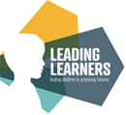

Autumn 1
What are we learning in Year 3?

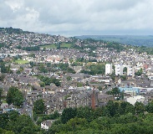

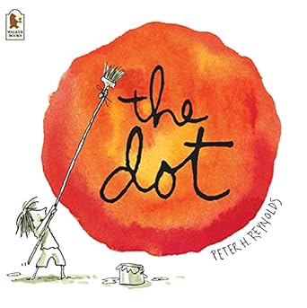
English
Peter H. Reynlod’s The Dot is a great book showing how to build resilience and how everyone has their own creativity and special talents. We will be writing our own playscript for the story using a thesaurus to upskill our words.

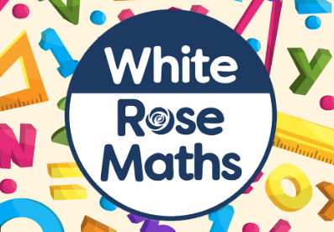
Maths
Our focus in maths this half term will be Place Value focussing on numbers up to 1000. We will be securing our knowledge of our times tables and multiplication facts for the 2’s, 5’s, 10’s, 3’s, 4’s. 6’s and 8’s.

Geography
This half term we are looking at the similarities and differences between Keighley and Malham. We will learn about physical and human features in the two places.
The children will have the chance to explore Malham and look at the features we have identified in our research working alongside the National Trust.
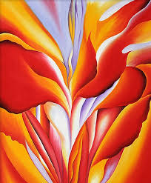
Computing
Online safety is a crucial part of the curriculum. We will discuss the importance of passwords, how communities connect, together, using the Internet and understand that not everything on the Internet is true.
Science
This terms topic across every year group is animals including humans. Year 3 will be focusing on bones and muscles of humans and the different types of skeletons animals have. We will also consider diets and how to stay healthy.

Art
Drawing will be the element of art that we study this half term. We will explore composition and
scale to create our own abstract drawings. We will do this through our developing understanding of how to create tone and texture in our drawings.
shading.
To understand how
texture can be
created and used to
make art. .

Religious Education
What faiths and beliefs can be found in our country and community? This is our key question in RE. We will look at different places of worship in the local and wider community and their significance to believers.
Spanish
In Spanish lessons with señora Priestley we will be consolidating our knowledge from previous years reinforcing the vocabulary of greetings, colours and numbers through songs and games.
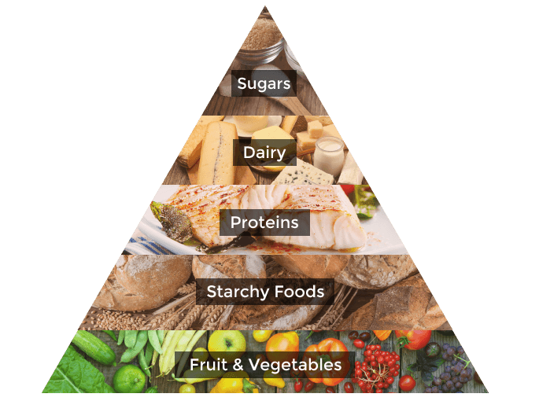
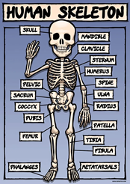


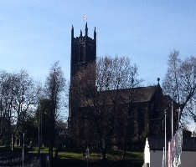
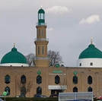

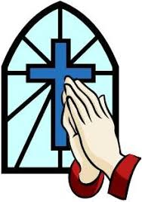

PSHE
Our focus throughout Autumn 1 is ‘’Me and my relationships”. In year 3 our PSHE will cover why we have rules, how to solve problems, and identify qualities of friendship.

