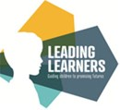

Autumn 1   
What are we learning in Year 1?

Reading books will be changed on Friday however, please can children bring their books to school every day, PE days are Mondays and Fridays please can we ensure children have full PE kit on these days.

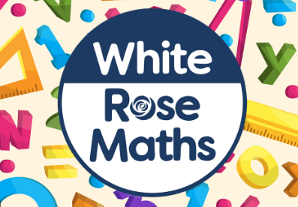Maths  
Our focus in maths this half term is place value (within 10).

English

This half term in English we are looking at 5 lovely non-fiction stories from 5 contrasting authors we will be mapping out the stories and looking at the characters and plots in detail.

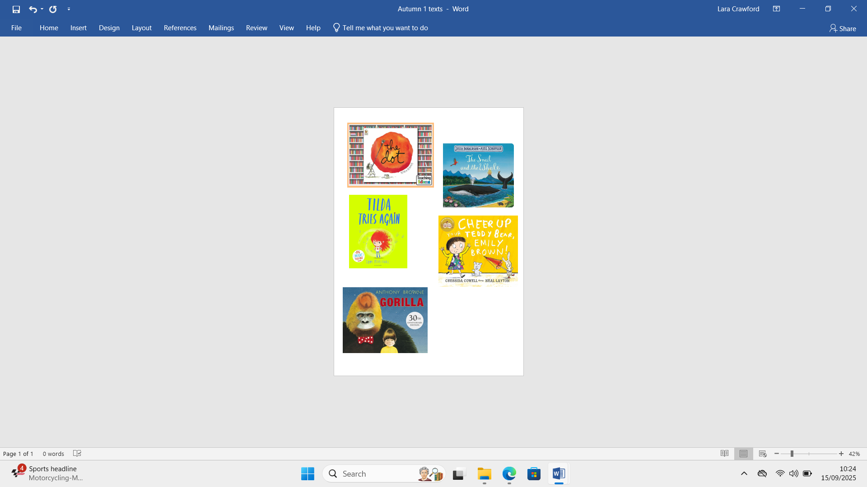

**We are very impressed with your fantastic start to year 1! Keep up the good work guys.**

**Miss Crawford & Miss Milner**

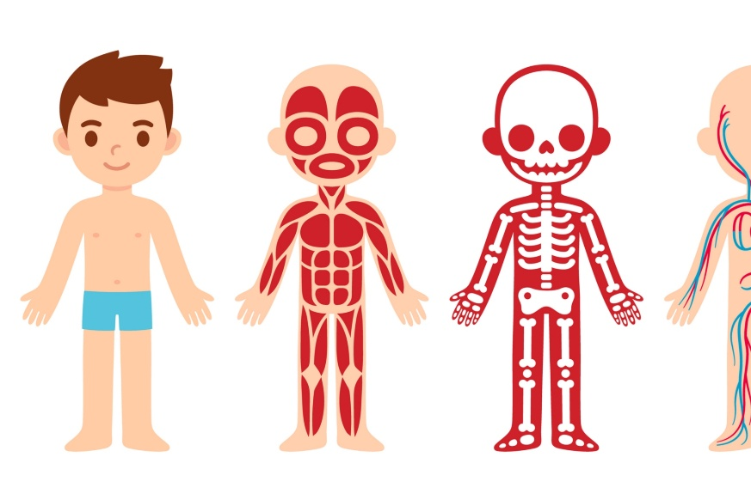

**Science**

In Science we are learning about our bodies, we are learning our different body parts and all about the five senses.

**Computing**

We are learning all about internet safety.

. 

Geography  
Our Geography topic for this half term is ‘What is it like here?’ We are learning about where we live, aerial maps and our school surroundings.

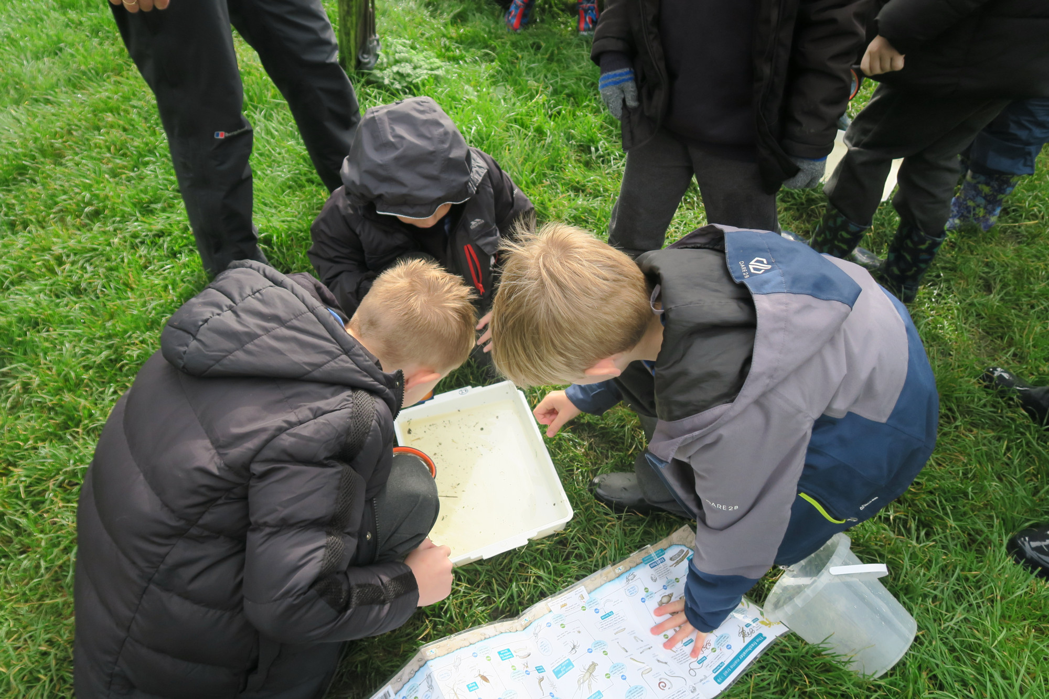

**Art**  
In art we are leaning different drawing techniques and how to mark make using a variety of equipment.

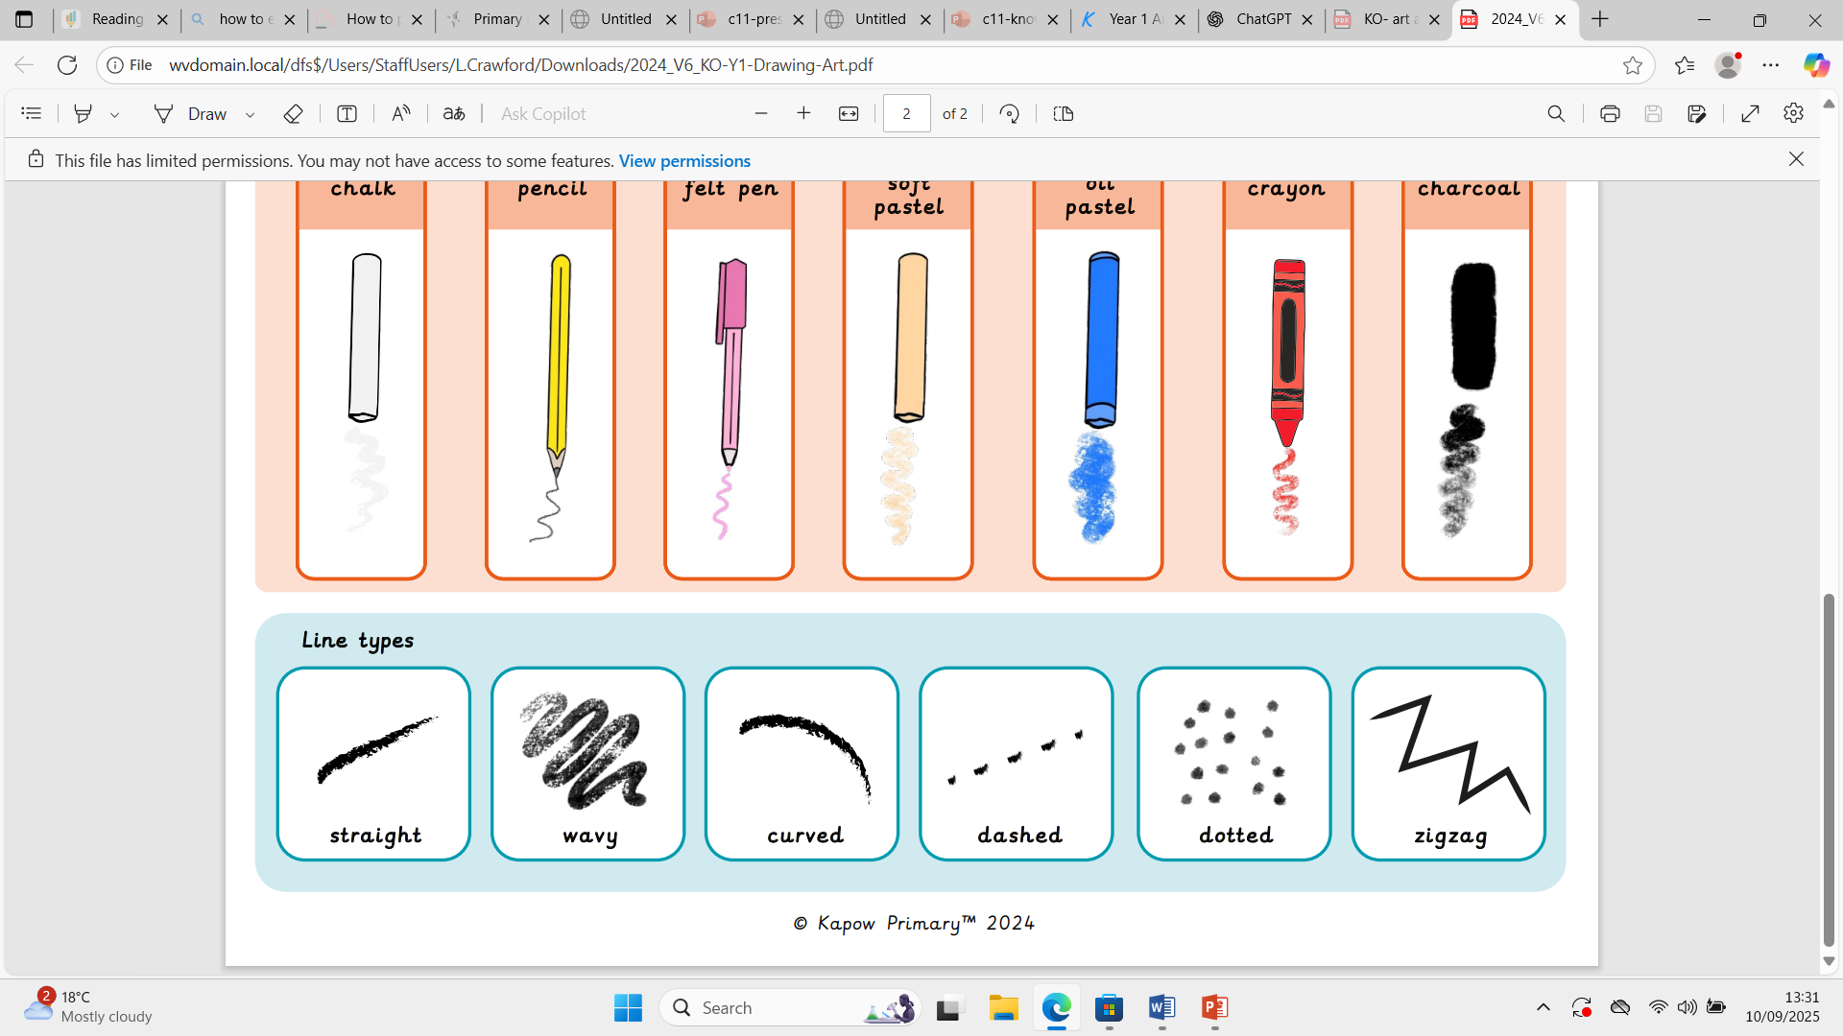

**Religious Education**

In RE this half term we are learning all about why people choose to belong to a religious community. 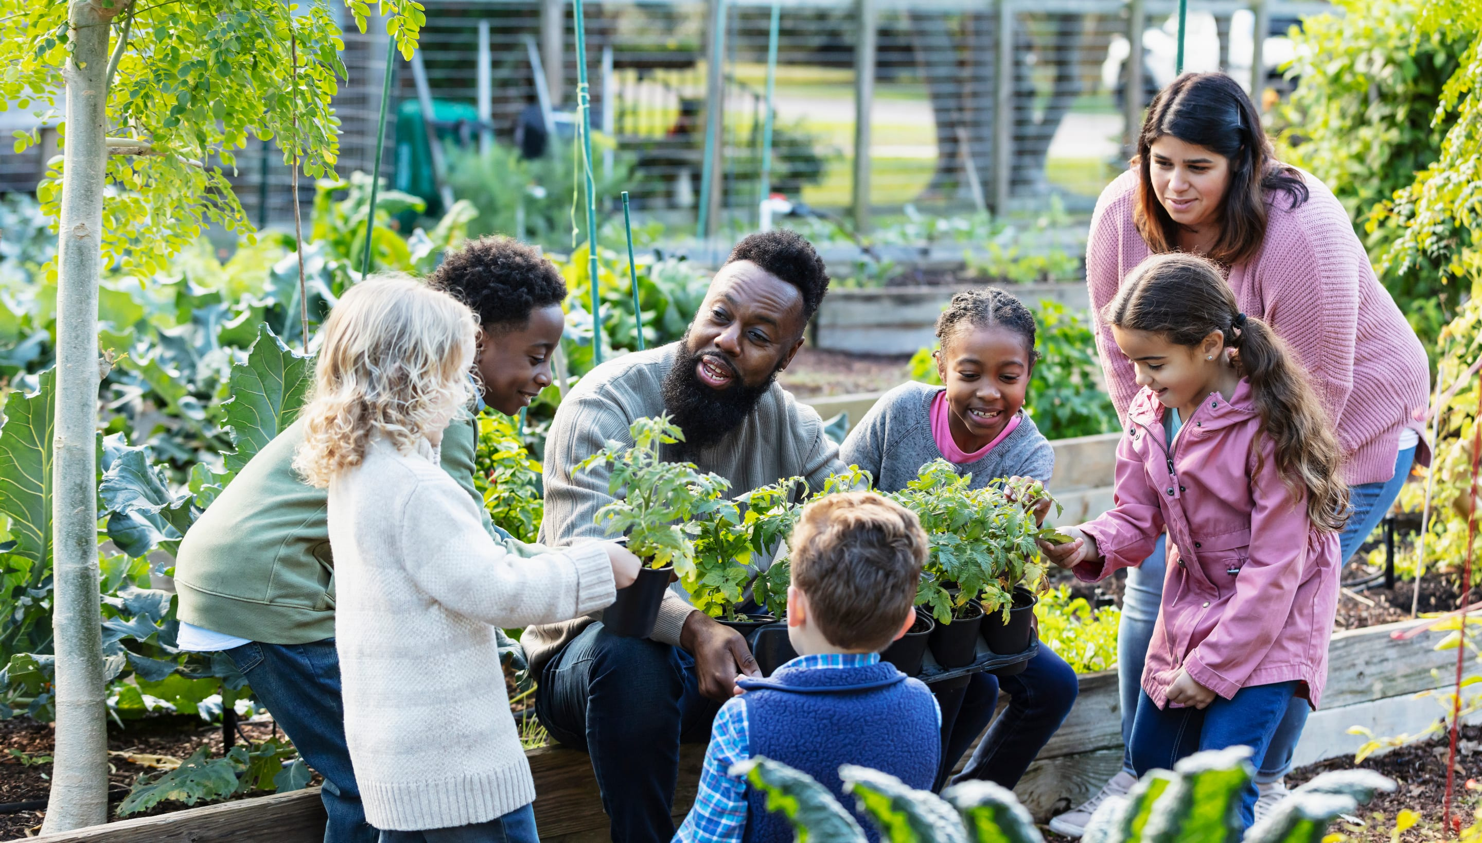

  
**PSHE**

In PSHE this half term our topic is me and my relationships and we will be learning about classroom rules and how to listen and respond to our feelings.