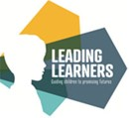

Autumn 1  
What are we learning in Year 5?

English  
This half term we are reading ‘The Viewer’ by Gary Crew and Shaun Tan. We are learning how to write exciting sentences so we can compose our own poems.

Geography  
This half term we are focusing on The Alps. We will be learning about the physical and man-made features of this mountain range and the part that tourism plays in it.

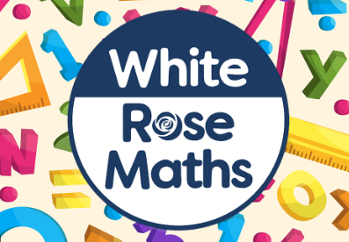  
Maths  
Our focus in maths this half term is rounding numbers to the nearest 10, 100, 1,000, 10,000 and 100,000..

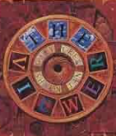

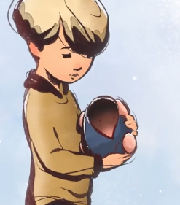

Art  
This half term we are learning about how to make gestural and expressive marks to capture emotion in our artwork.

  
PSHE  
Our focus throughout Autumn 1 is ‘Me and My Relationships’. We will be looking at what makes a good friend and the foundations of healthy friendships.

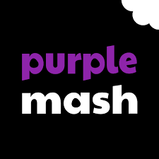Computing

We will be learning about online safety and concept maps.

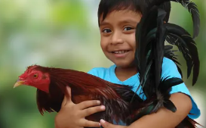  
Science  
We are learning about animals, including humans. We will be looking at gestation and how this differs across animals. Applying our mathematical skills to data- collection, we will be learning how to represent scientific data in line graphs and bar charts.

  
Spanish  
We will be learning about healthy eating, carnivals, colours and clothes descriptions. We will be understanding singular and plural use and the verb to be and to have.