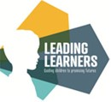

Autumn 1

What are we learning in Reception?

Key texts and topics.

Welcome to Reception, now that we’re all settled in I thought I’d share some information. We’ve got a busy few weeks ahead of us!

We will be spending this first half term getting to know each other, starting school is an important milestone which will celebrate in lots of different ways. We will be reading lots of fantastic stories about families, choices and Cats of all sizes . Here’s some of the texts we’ll be sharing…

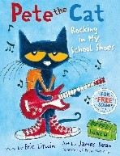 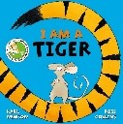 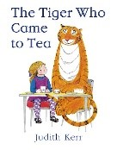

Physical Development

Through our outdoor provision and hall time we will be learning new games and action rhymes and developing our skills using tools and equipment. We will be also learning to get dressed and undressed for P.E so your child will need a P.E kit in school (please write their name in everything!) In preparation for writing we will be practising our letter formation, you can do this at home using the formation rhymes sent hometo help.

P.S.E.D. and 

We will be learning to be independent, follow routines and instructions.

We’ll also be talking about caring for ourselves, our family and friends, how we’re feeling and who can help us.

SCARF – Me and my relationships

* All about me
* What makes me special
* Me and my special people
* Who can help me?
* My feelings

My feelings (2)

Communication and Language

We will be talking about our favourite things and learning new words through the stories and discussions we have with the aim of learning to:

Ask a variety of questions

Tell others about our thoughts, feelings and opinions

Listen and respond to others appropriately

Apply new words in every day conversations

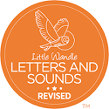

We will be learning our first sounds, 4 each week-

s,a,t,p i,n,m,d g.o.c.k ck,e,u,r h,b,f,l,

Please look out for the resources we send home to help, we will start to pend reading books home from the week commencing 6th October. We send them home on a Thursday. Please return them the following Thursday. Sign and date the yellow reading record when you read with your child at home.

How you can help your child at home

Please talk to your child. Ask them about their day.

Please read at home! Whether it’s stories, words on cereal packets, letters, magazines, reading is everywhere, enjoy reading with your child and they will enjoy reading to you.

Practise the new sounds and tricky words we send home each week.

Count- forwards and backwards, count the stairs as you walk up them or the bricks your child has used to make a tower. You could also ask your child how many there’d be if we got 1 more or how many if we take one away.

Encourage your child to be independent and to look after their things at school. It would also be a huge help if you could label their uniform with their name. Thank you for your support.

If you would like to get even more involved in your child’s learning we have a number of opportunities that we would love your help with. If you’d like to bake with the children, share stories, or you’re a keen artist or musician speak to one of the team and we’ll welcome you into school with open arms.

Expressive Arts and Design   
We will be exploring different media and materials to paint, print, collage and draw.

We also have our own Drawing Club which every child takes part in. We learn new words and actions and retell stories by drawing our ideas.

Understanding the World

We will talk about being healthy, our senses and how we have changed since we were babies.

We’ll be looking at how things have changed over time using our stories to help us.

As the weather changes we will also be thinking about Autumn and having our own Harvest Festival.

We’ve also got a trip to a working farm to look forward to on October 2nd. Please give consent for your child to attend via parent pay.

Maths  
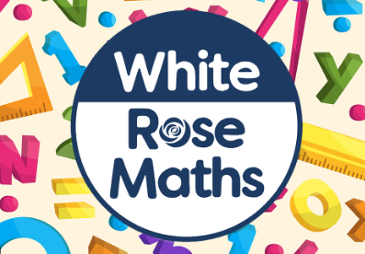

We will start our maths learning with counting, matching, sorting and comparing both numbers and amounts and shapes.

We will also look at patterns, repeating patterns and creating our own.